Client Meeting Notes -- SERAPHIM
Friday, October 10th, 2014
Clients: Ms. J’aime Pfeiffer and Ms. Jen Cannell
Team Members: Kevin Mango, Lauren Mathews

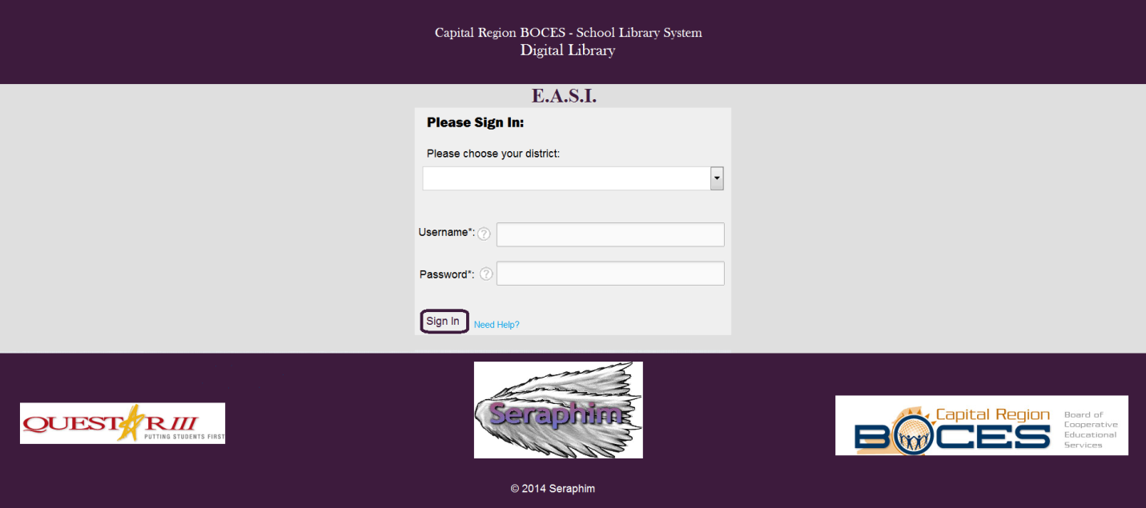
Loginscreen

Main Page
Let's start with how we expect users to login to the system, following the loginscreen.png and the loginscreen - explanations.png files.

- The login screen will be the first screen all users encounter when entering the URL address for E.A.S.I.
- The login screen will have the following features (these might change from how they're presented in the picture):
- A drop down listing every district that is available for the system
- A username and password to access the system
- A small tutorial (located as a ? next to the end of Username: ? and Password: ? in the loginscreen.png file) for where to find the username and password
- A "Sign In" button
- A "Need Help?" link, which provides a small pop-up explaining how to contact someone in charge (most likely the administrator in charge of maintaining the system)
- Any login attempts that fail will be represented with an error message that displays what goes wrong
- Question: What username system would you like to use? For example, a library card number, a combination of their first & last name, a totally unique number, etc.
Moving onto how the website will work, for all users (we will get to user specific features next), and is based off the website.png and website - explanations.png files.

- The main page of the website, as shown in the website.png, is what all users will first encounter when correctly entering into the system (providing the right district, username and password credentials).

- The website will have the following pages:
- The main page, as shown in website.png.
- "My Account", a page to organize their account settings.
- "Genres" will be a drop-down that leads to pages that have all the Fantasy books, Science Fiction, etc.
- "Subjects" will be a drop-down that leads to pages that have all Science, Math, History, etc, books.
- A page to show all possible Genres and Subjects, with the amount of books available in each topic
- "Levels" will be a drop-down that leads to pages that have only books for certain levels.
- Searching in the search box will lead to the "search" page, which shows all the books found for the inputted text.
- Clicking "Advanced Search" will lead to a separate page to search using advanced settings.
- Clicking on any book cover will lead to a single page with that book's information.

- All pages of the website will have:
- The "header" (the top of the page; everything along the menu, such as the "Genres" and Search bar, and above)
- The "footer" (the bottom of the page, where the images for Questar III, Capital Region BOCES, and Seraphim, are)
- A logout button/link (not shown in loginscreen.png)
- Whenever books are displayed (such as on the main page, searching, or in Genres/Subjects/Levels), they will show:
  - The book cover
  - Whether the book is available as viewing (default), downloadable as an e-book, or downloadable as an audiobook
  - When scrolling over the book image, a small, transparent, "block" will pop up over the book cover, displaying the title and author
  - Clicking on the book cover leads to a page that displays more information about that book
  - A download button, with an arrow, below the book; clicking the download button allows you to download the book as an e-book (default), while clicking the arrow allows you to choose to view or choose a download option (if the book is available in multiple formats, such as e-book and audiobook)
  - Books will only appear depending on the user's level (talked about more in #8)
  - Books will display in rows/columns, and will only have so many rows; there will be a "Next Page" and "Previous Page" options at the bottom

- The main page will have the following features:
- A set number of books, in rows/columns
- All books will be randomly selected, from the database, of available books from the district for that user's level
- The books display method (as discussed in #3)

- The "My Account" page will have the following features:
- The ability to view their username, user account type (either student, teacher or administrator), and their district (students + teachers will not be able to change any of these)
- Individual abilities as dictated by their user account type (for example, administrators adding/removing vendors)
- Question: Do students need to have an email address attached to their accounts? If so, should they have the option of changing that email?
- Question: Do students have individual, unique, accounts (each student has their own account) to each of your vendor sites, or is there one central account that they all login to? Depending on the answer to this question, our system will reflect on how we "connect" the accounts to the vendor sites.
- Question: What other information would you like to have any user have access to (any library information, for example)?

- The "Genres" will include:
- The following genres: Biography & Autobiography, Comic & Graphic Novels, Drama & Literature, Historical Fiction, History, Humor, Mystery & Thriller, Romance, Science & Nature, Sci-Fi & Fantasy, Fiction, Non-Fiction, Arts, Business & Finance, Education, Law, Medicine, Multicultural Studies, Religion, Social Science, Technology, Adventure, Audiobooks, Classics, Film, Horror, Music, Philosophy, Picture Books, Sport, Thrillers
- Genres will appear in alphabetical order
- These Genres will only show in the drop down menu if the topic is available (if there are 1+ books in the category)
- To ensure that the menu drop down doesn't get too long, only the first 6 or so options will appear; the last option will be to "See all Genres", which will lead to a page that:
  - Will show ALL Genres and the amount of books available in each genre

- The "Subjects" will include:
- The following subjects: Language Arts, Mathematics, Science, Health, Physical Education, Art, Music, Foreign Languages, English, Social Science, Technology
- Subjects will appear in alphabetical order
- These Subjects will only show in the drop down menu if the topic is available (if there are 1+ books in the category)
- To ensure that the menu drop down doesn't get too long, only the first 6 or so options will appear; the last option will be to "See all Subjects ", which will lead to a page that:
  - Will show ALL Subjects and the amount of books available in each genre
- Question: Are there any missing subjects? Are there any subjects you'd like not to have?

- The "Levels" options:
- When choosing a level, one will see all books found for that level
- Students in higher levels have access to books in lower levels
- Question: How much do we want to restrict which students can access what books? Do we want restrictions at all? Should students be able to access books that might be considered "too old" for them?
- Question: If yes to the above question, what levels would you like for the system? (Assuming teachers and administrators can access all levels). For example, a student could be in 5th grade, and have access to K-5 Level books only. A student could be in 12th grade and have access to K-5, 6-8, and 9-12 Level books. The supposed levels, for now, are based off grades.

- Searching/Advanced Search options:
- Any search part will lead to a page that shows all book options. If none are found, it will show the message "No books found!"
- Searching involves entering in book title, author or ISBN-13
- Advanced Search will at least be able to:
  - search parts available in normal searching
  - search in any number of categories from Subjects, Genres, or Levels
  - search for viewing, e-books or audiobooks
- Question: Are there any other filters you wish to have for advanced searching (language, file type (mobile or computer), etc)?

- Book Descriptions pages will have:
- A bigger version of the book cover
- Full description of the book
- Title, Author, ISBN-13, Publisher information
- The ability to view/download it
- Question: Is there any other information that you'd wish to have available?

- Question: All of this describes the format we expect the website to be in. Nothing is set in stone yet. Is any anything here that you'd like to change/add/remove?
Now, to express how each of the user type accounts will act:
- Students:
- All users will have full Student privileges
- Download/view e-books available to their district/level(s)
- Teachers:
- All administrators have teacher privileges
- View student account information (username/password) (through Settings in the "My Account" page)
- Access to teacher e-books (which will be their own Level)
- Administrators:
- Adjust usernames & passwords for all users (through Settings in the "My Account" page)
- Add/remove vendors (through Settings in the "My Account" page)
- Question: Is there any limit to the number of e-books a student/teacher may "have" at once? Should an administrator be able to adjust this limit, if one exists?
- Question: Is there anything else any user type should be able to do?
And, finally, what the system (E.A.S.I.) will be doing in the background:
- As administrators add the credentials for a vendor site, the system will automatically "grab" the e-books from the site, along with the information, and incorporate it into our database
- As users download/view an e-book, the system will automatically "inform" the vendor site
- The system will handle all internal requests, such as search, clicking, logining, etc.
- Question: What information do the vendor sites need when a user downloads a book? For example, can only 1 user from a district download a specific book at once, or can multiple? What we want to know is how users interact with the vendor sites right now.

- Discussed the general layout for E.A.S.I interface using prototype images
- Overall layout was satisfactory, a few modifications requested to add project name to log in screen, and Questar III to title on log in and main pages
- Requested features include:
  - Statistical information to allow for tracking of site popularity, this would allow them to
  - decide what vendors to keep paying for and what ones to drop (only accessible by
  - administrators)
  - Automatic log out on browser close
  - Student level restrictions
    - Current grade restrictions used on Overdrive split between elementary and secondary, where elementary is grade 5 or less, and secondary is anything above grade 5
  - Desirable to completely remove visibility of higher books from lower level students all together
    - Current level restriction system allows students to see the books they can't check out
  - Allowing teachers and administrators to promote students levels prematurely
  - Allow students unlimited check out of books
  - Currently Rosenberg allows for unlimited check outs but Overdrive only allows 3. This means a check would need to be made a on a per vendor basis to determine if a book needs to be returned before a new check out can be made from that vendor
  - When adding a new vendor request a limit to check outs from that vendor
- Credential system lacks uniformity
  - Rosenberg uses a single sign on credentials per district or school, Overdrive requires unique credentials per student
  - Some districts may use a 13 digit library card as a password while others might use a grade level based password
  - A sampling of vendors will be necessary to determine a range of possible log in formats
  - Some vendors may not be intractable with the system without modifications post deployment
- Some sites allow in browser viewing of e-books, others may have a file download. These files might also have an expiration timer, in which case an automatic check out update could be sent to the vendor.
- Administrators can add and remove other admins

